**tasks on route53, s3, CloudFront**

**1.Configure VPC peering in cross regions**

**\***create vpc’s with 1 private and 1 public subnet in two different region

*go to peering connection and follow the steps and add vpc of different region by selecting option provided

*accept the request in the region you provided before.

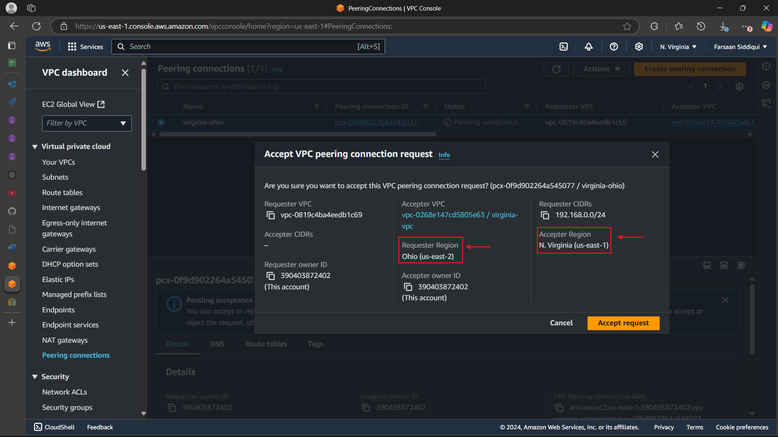

*add the CIDR range in the rt for both region vpc

*one region in public rt

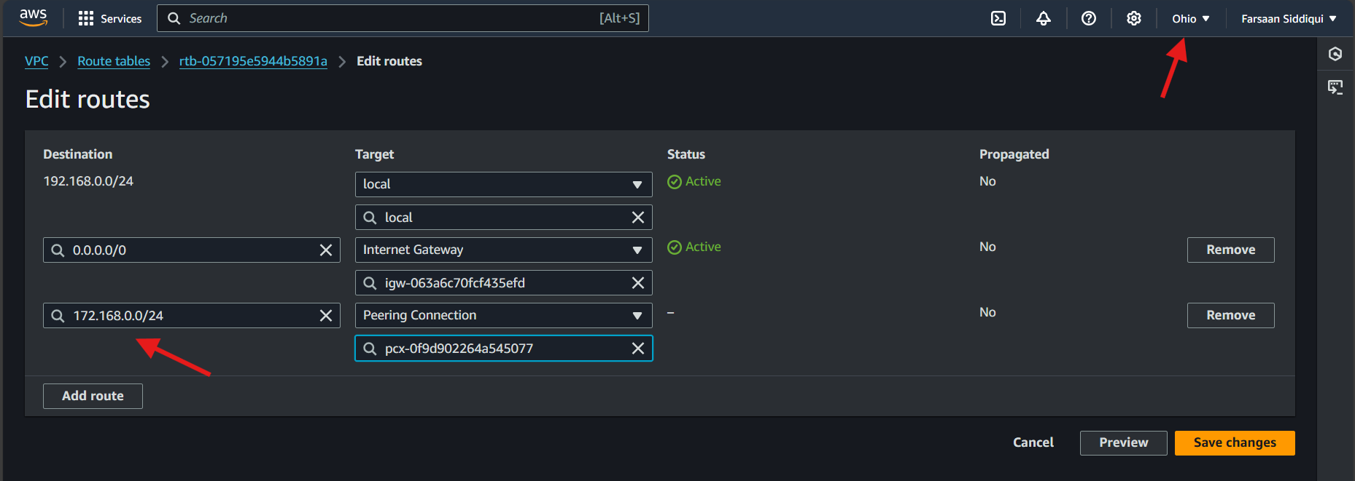

*one in private rt

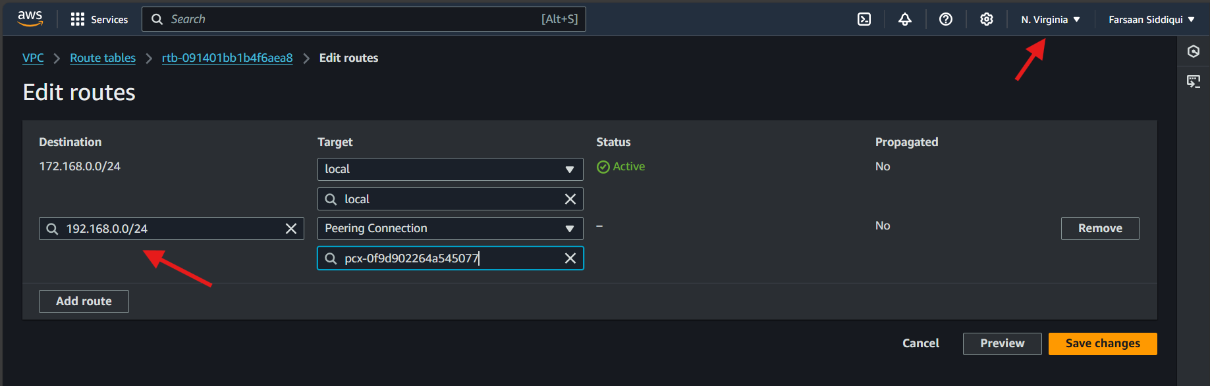

*create ec2 instance in both regions (1 with public subnet and other with private subnet)

*login in with the instance which has igw the public one and try ping the private ip of instance cretaed with private subnet with no igw

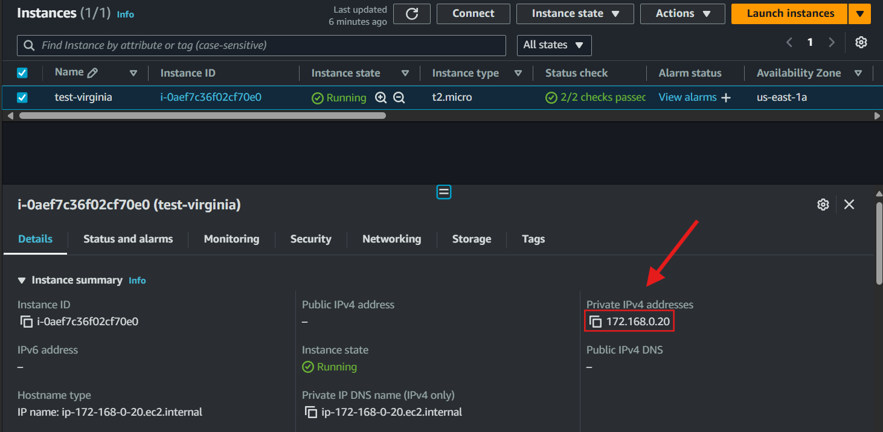

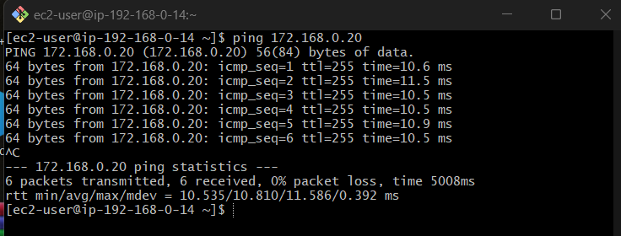

**2) Purchase one domain from GoDaddy.**



**3) Deploy static website in s3.**



*checking the website by the link of s3 bucket

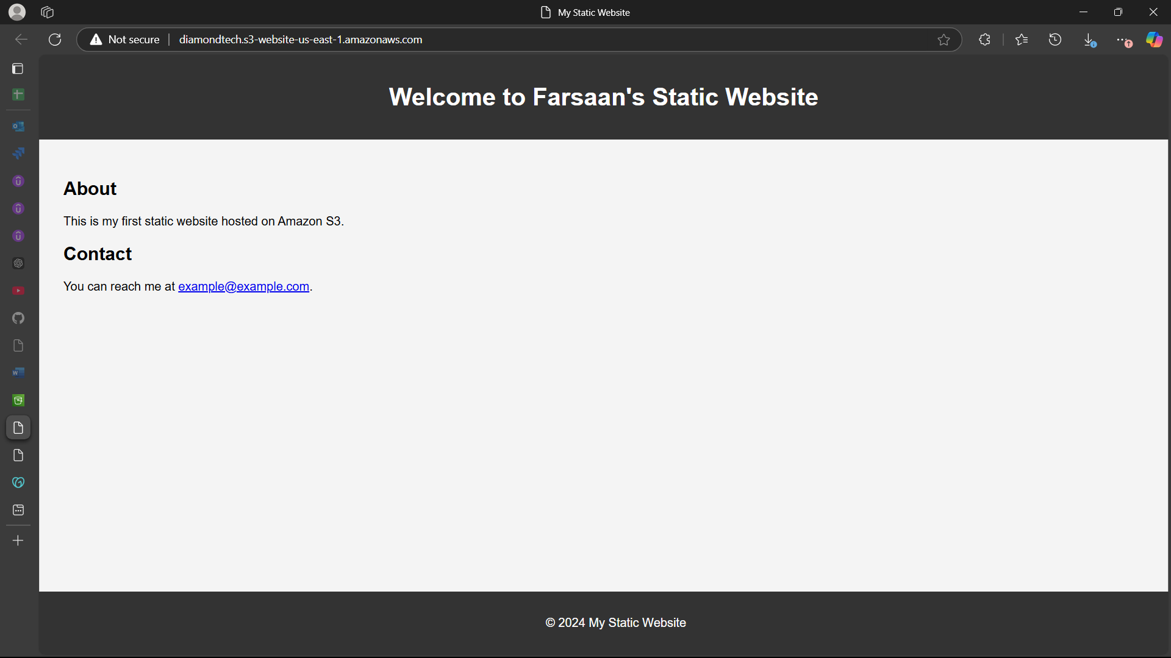

**4) Create CDN and attach one SSL certificate.**

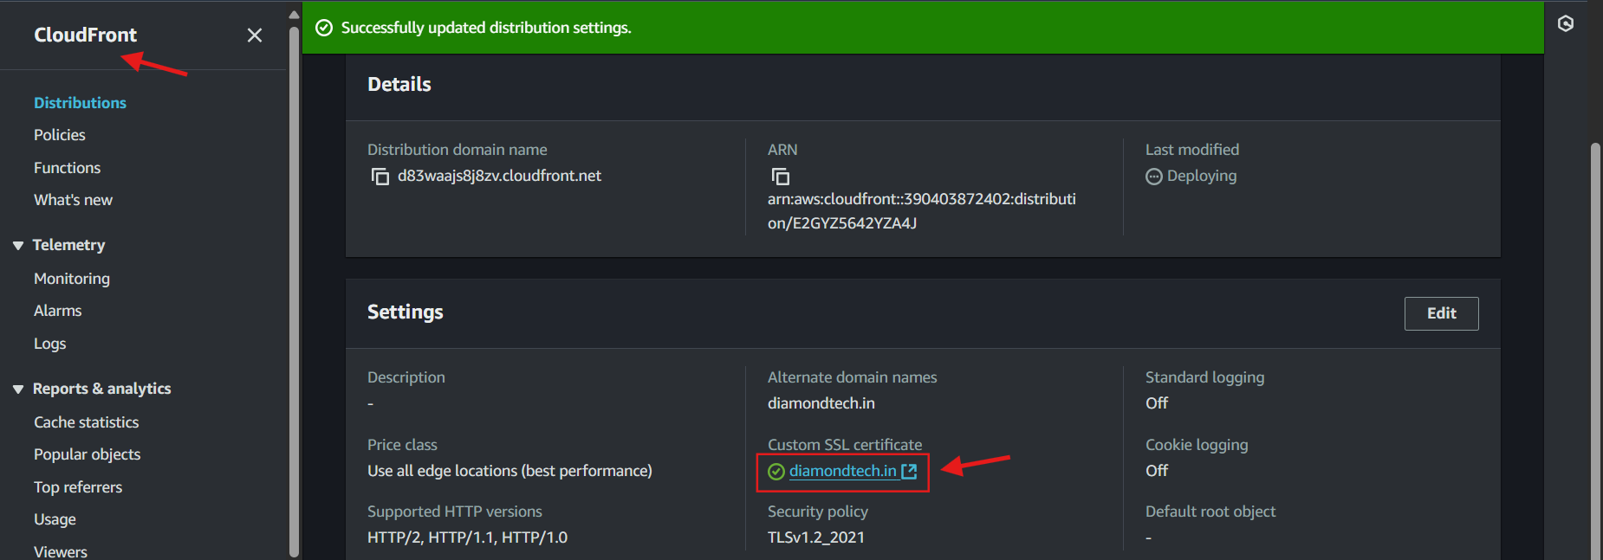

**5) Create Route53 hosted zone and MAP the domain with CDN.**

*create record in route53 and click alias and select cloudfront and the vale of cloudfront

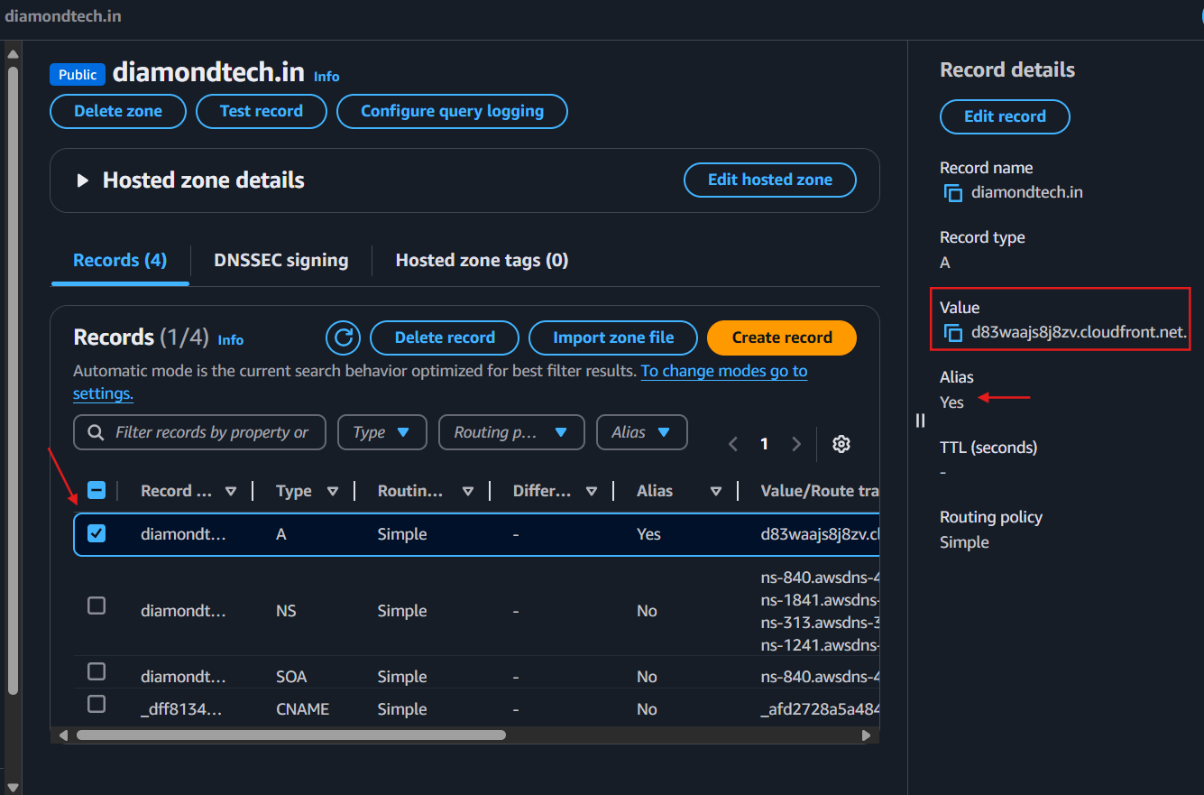

**6) Update the index.html in s3 bucket and the updated file should be accessible by using domain name.**

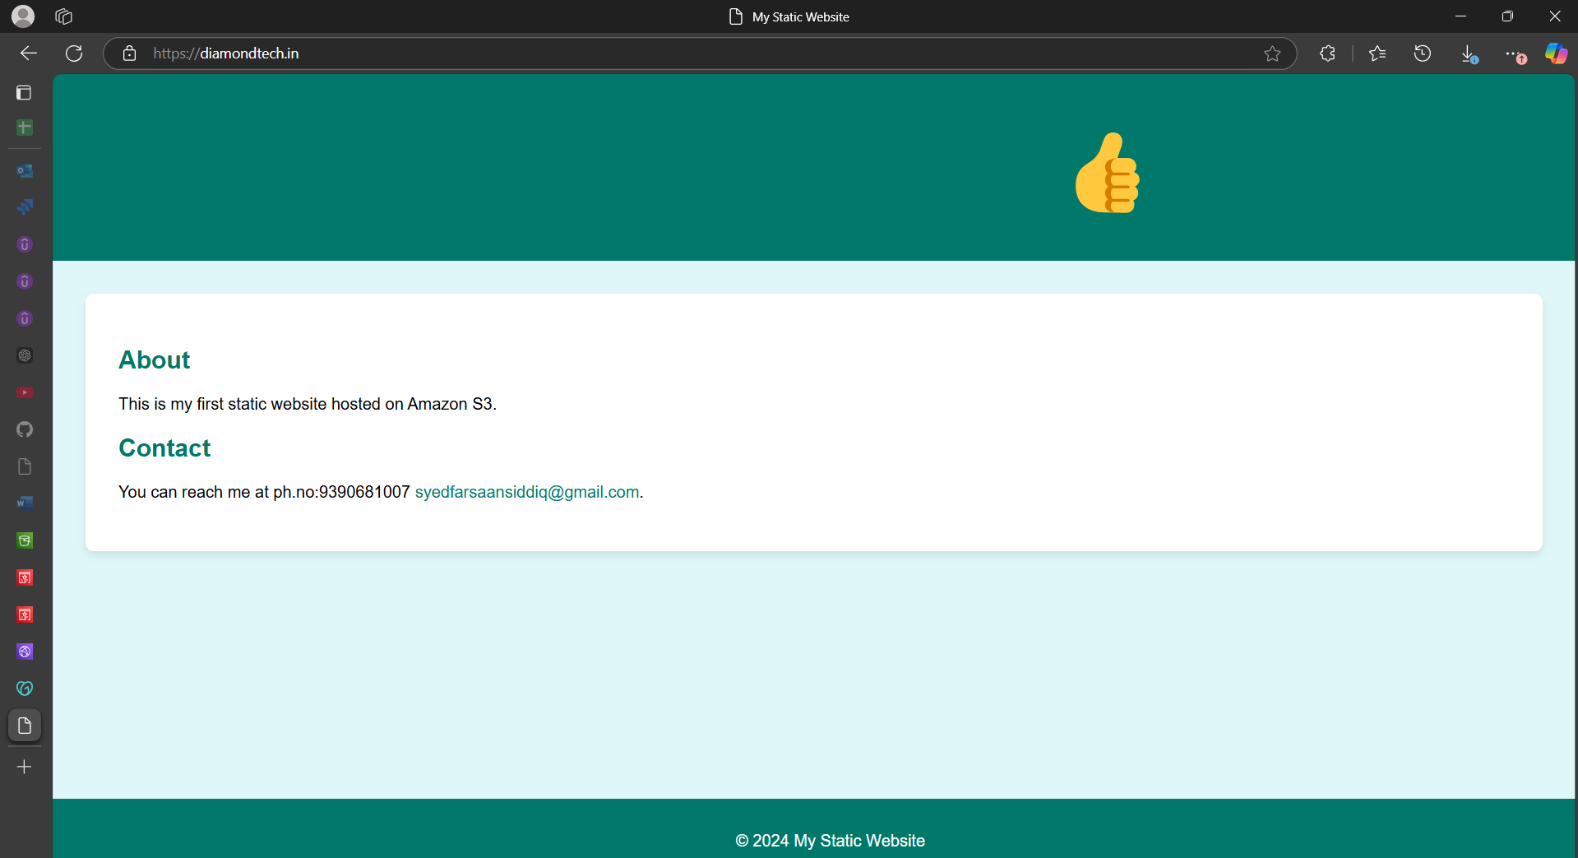

**7) Share the Domain name in slack to test the connectivity.**